Basic shell script:
Created a directory Bharath/scripts
Created a file helloworld.bash
Edited the file using bash script
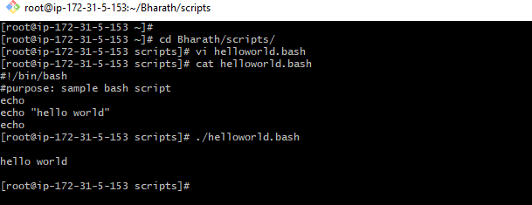
Defining commands task:
created a file small-task-bash in a director Bharath/scripts
Edited the file small-task.bash with vi small-task.bash
By using bash script executed basic commands of linux
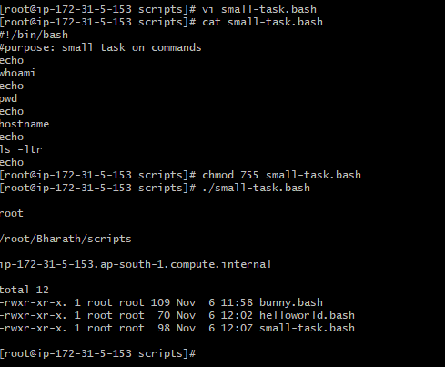

Defining variables:
created a file basic-variables-task.bash in a director Bharath/scripts
Edited the file basic-variable-task.bash with vi basic-variables-task.bash
By using bash script executed variables value as output

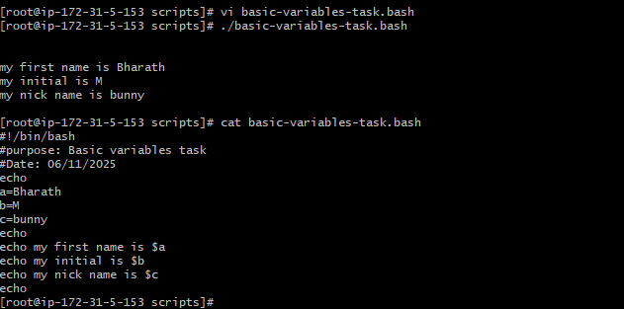

Read input:
created a file basic-read-task.bash in a director Bharath/scripts
Edited the file basic-read-task.bash with vi basic-read-task.bash
By using bash script executed read task .

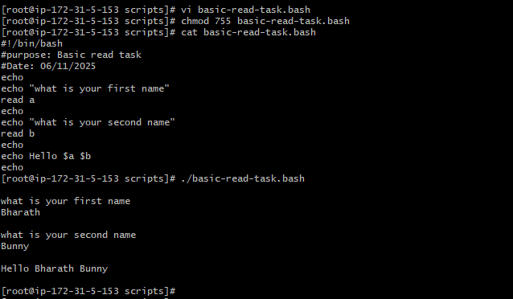

Script to run commands within :
created a file script-within-commands-task.bash in a director Bharath/scripts
Edited the file script-within-commands-task.bash with vi script-within-commands-task.bash
By using bash script executed task .

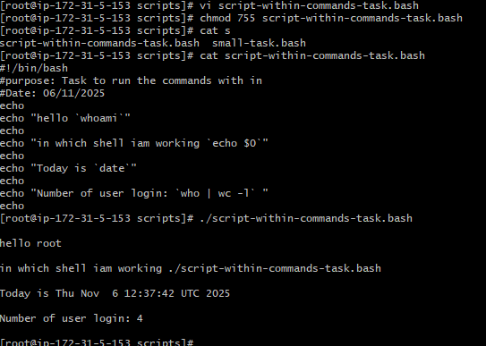
Read input and perform a task.
Created rename-task.bash in a directory Bharath/scripts
Created a file rename-task.bash and edited that file using command vi rename-task.bash
Executed the task using bash script to rename the file name from older file name to new file name
